Glittering, shimmering.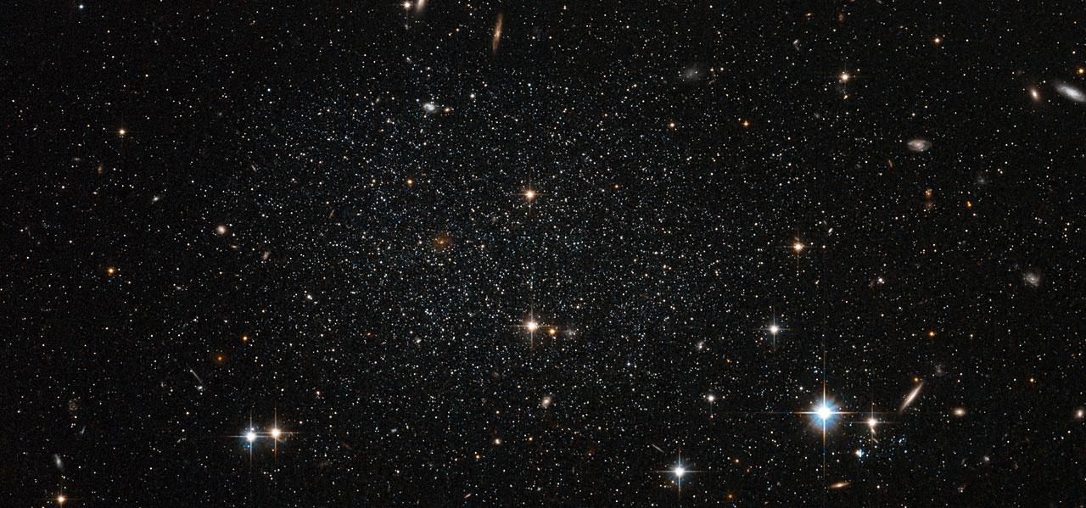

Sparkling like diamonds.

Giving light in a tiny way.

Always hiding beyond the day.

Keeping eyes over space.

Nora Mariud 14.08.2017